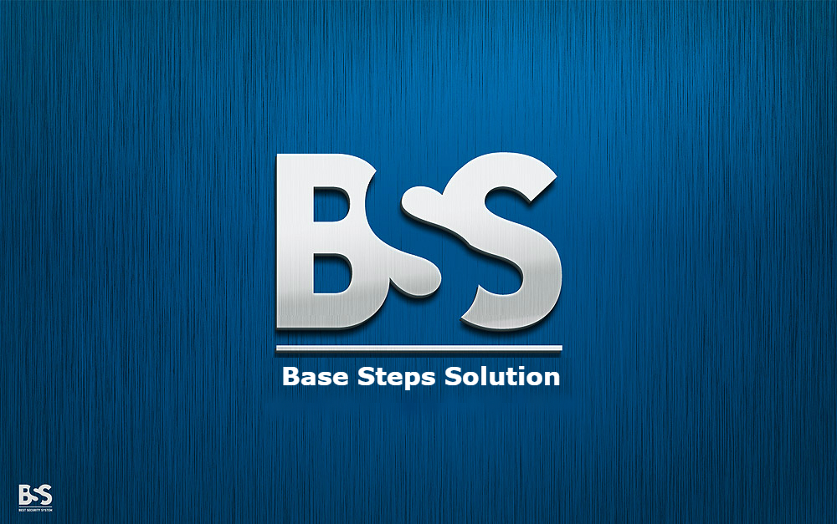

Vision & Scope

Van Lang Admissions

# Revision Table

|  |  |  |  |
| --- | --- | --- | --- |
| Author | Date | Reason for changes | Version |
| Minh Đoàn | 16/11/2016 | Initial the document | 1.0 |
|  |  |  |  |
|  |  |  |  |

Contents

Revision Table 1

1. INTRODUCTION 3

1.1. Purpose 3

1.2. Audience 3

2. Business Requirement 3

2.1. Background 3

2.2. Business objective and success criteria 3

3. Vision of solution 4

3.1. Vision statement 4

3.2. Major feature 4

4. Scope and limitations 4

4.1. Scope of initial release 4

4.2. Scope of subsequent release 4

4.3. Limitations and Exclusion 5

5. Business context 5

5.1 Stakeholder profile 5

5.2 Project constrain 5

5.3 Operating environment 5

# INTRODUCTION

## Purpose

* This document is description about vision and scope of Van Lang Admissions project. It shows the vision what BSS – Team wants to toward and the scope of project for BSS – Team doesn’t exceed the limit of project.

## Audience

* The main audiences of this document are: Mentor, Base Steps Solution Team and customer.

# Business Requirement

## Background

## Business objective and success criteria

* Business Objective 1: Help admin and editors manage News, Categories and Q/A more effectively.
* Business Objective 2: Introduce information and admissions news of Văn Lang University.
* Business Objective 3: Help Admissions Department of Văn Lang University manages admissions easier.
* Business Objective 4: Allow the aptitude exam candidates can register online.

# Vision of solution

## Vision statement

## Major feature

* Manage News
* Manage Categories
* Manage Student
* Manage Banner
* Manage Pop-up
* Manage Q/A
* Change Language
* Manage Account

# Scope and limitations

Văn Lang Admissions project includes three releases

## Scope of initial release

Release 1:

* Manage News
* Manage Categories
* Authorization

## Scope of subsequent release

Release 2:

* Manage Account
* Manage Student
* Manage Q/A

Release 3:

* Manage Banner
* Manage Pop-up
* Change Language

## Limitations and Exclusion

* Some features may be included in the software but not required:
  + View the admissions video
  + Comment the admissions video

# Business context

## 5.1 Stakeholder profile

* Customer is Văn Lang University and representative of customer is lecturer Nguyễn Thế Quang.
* BSS – Team.
* Mentor: lecturer Lê Sĩ Phú.
* User: admin, editor, reader.

## 5.2 Project constraint

* Start date: 1/10/2016
* End date: 30/4/2017
* Technical constraints:
  + Database: mongodb, elasticsearch, redit
  + Development language: JavaScript
  + Framework: AngularJs
  + Platform: NodeJs
* Quality attributes:
  + Performance
  + Modify
  + ,

## 5.3 Operating environment